Laura Bartlett

Lesson 7 Assignment

Source Code:

def calculate_product(number, product):

    product *= number

    return product

def main():

    try:

        numbers = [1, 2, 3, 4, 5, 6]

        product = 1

        for number in numbers:

            product = calculate_product(number, product)

        print(f'The product of the numbers is: {product}')

        print(f'The last number multipled was: {numbers[-1]}')

    except IndexError as e:

        print(f'Run-time error: {e}')

print("Completed by Laura Bartlett")

if __name__ == '__main__':

    main()

def calculate_product(number, product):

product *= number

return product

def main():

try:

numbers = [1, 2, 3, 4, 5, 6]

product = 1

for number in numbers:

product = calculate_product(number, product)

print(f'The product of the numbers is: {product}')

print(f'The last number multipled was: {numbers[-1]}')

except IndexError as e:

print(f'Run-time error: {e}')

print("Completed by Laura Bartlett")

if __name__ == '__main__':

main()

First, I ran the debugger and it gave a syntax error.

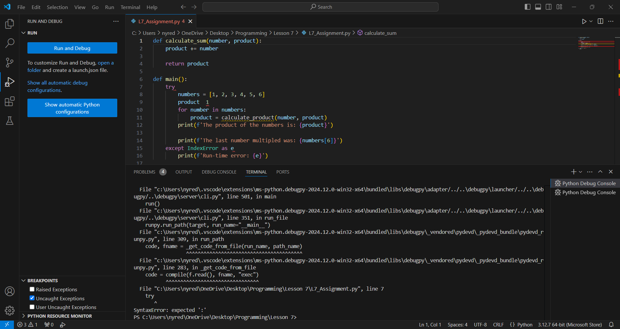

I fixed the ‘:’ after ‘try’, then ran the debugger again and got another syntax error.

After inserting the ‘=’ between ‘product’ and ‘1’, I ran the debugger again and got another syntax error.

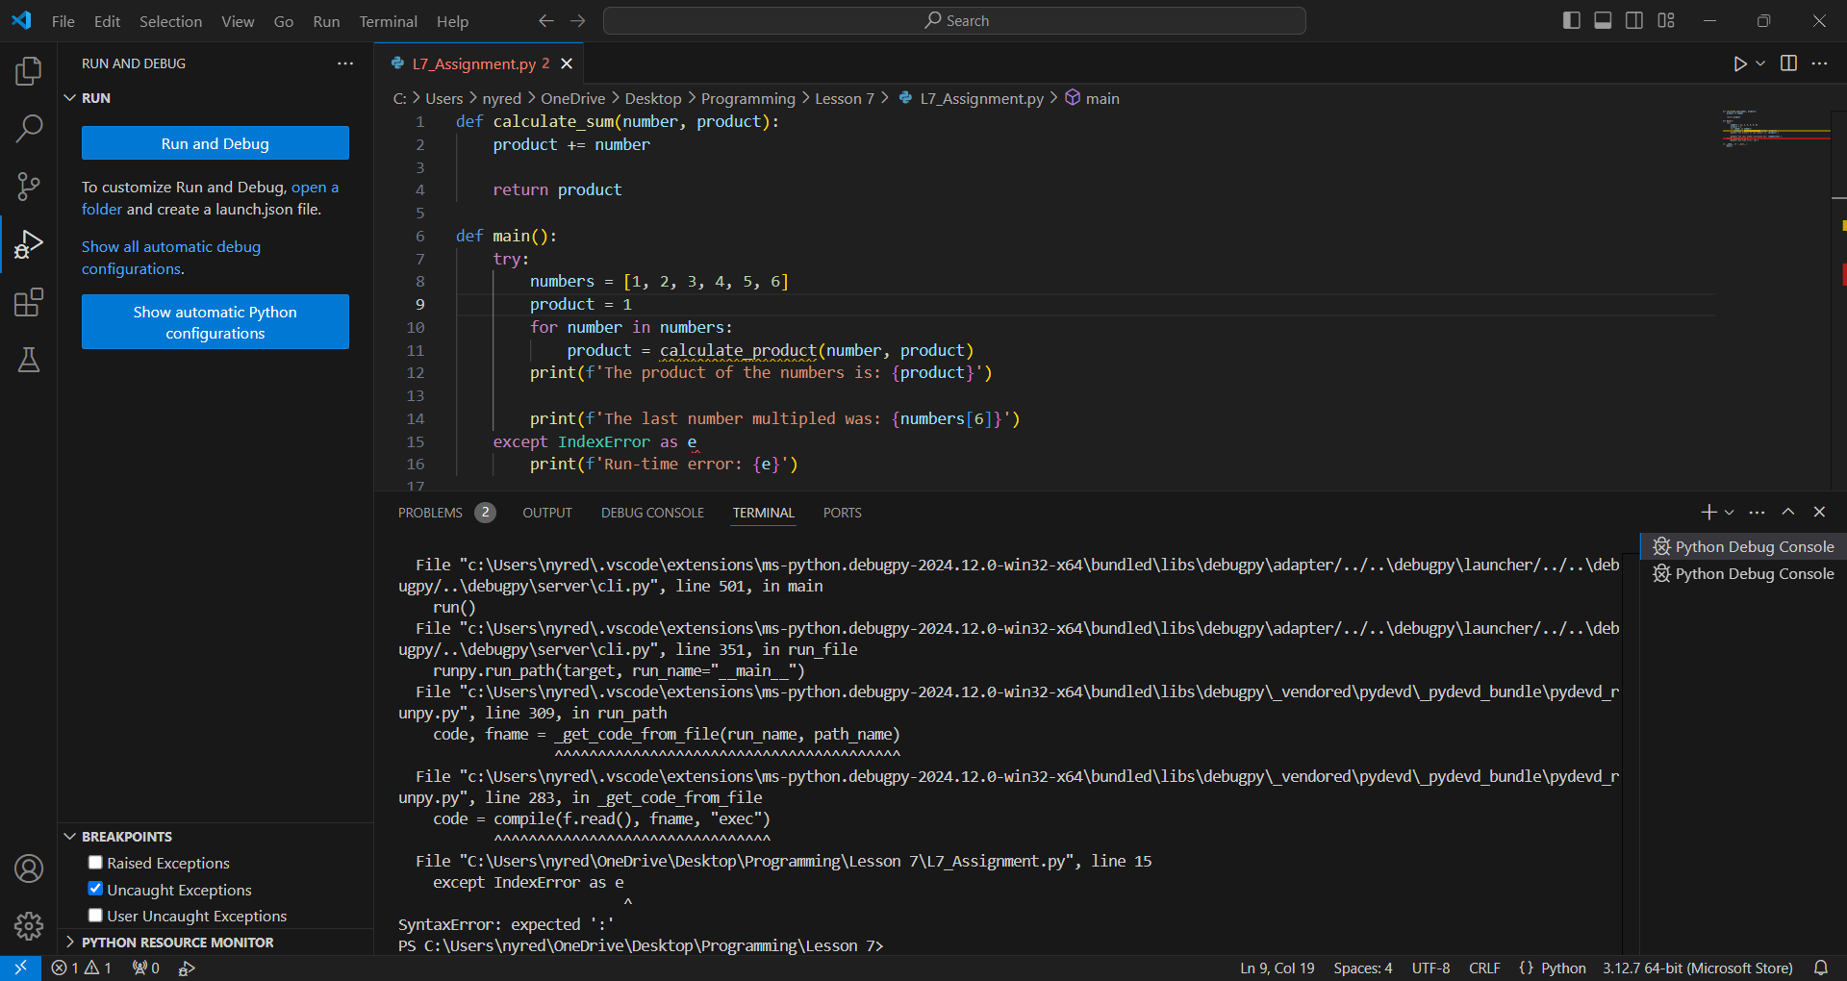

I added ‘:’ after ‘e’ and ran the debugger again.

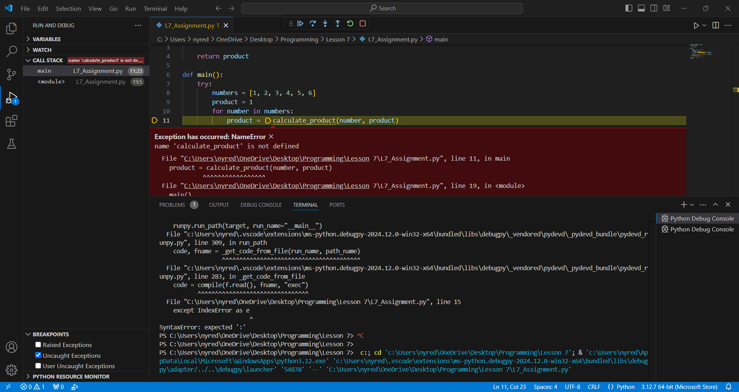

This time, there was a ‘NameError’ because ‘calculate_product’ was undefined. I corrected ‘calculate_sum’ to ‘calculate_product’ and ran the debugger again.

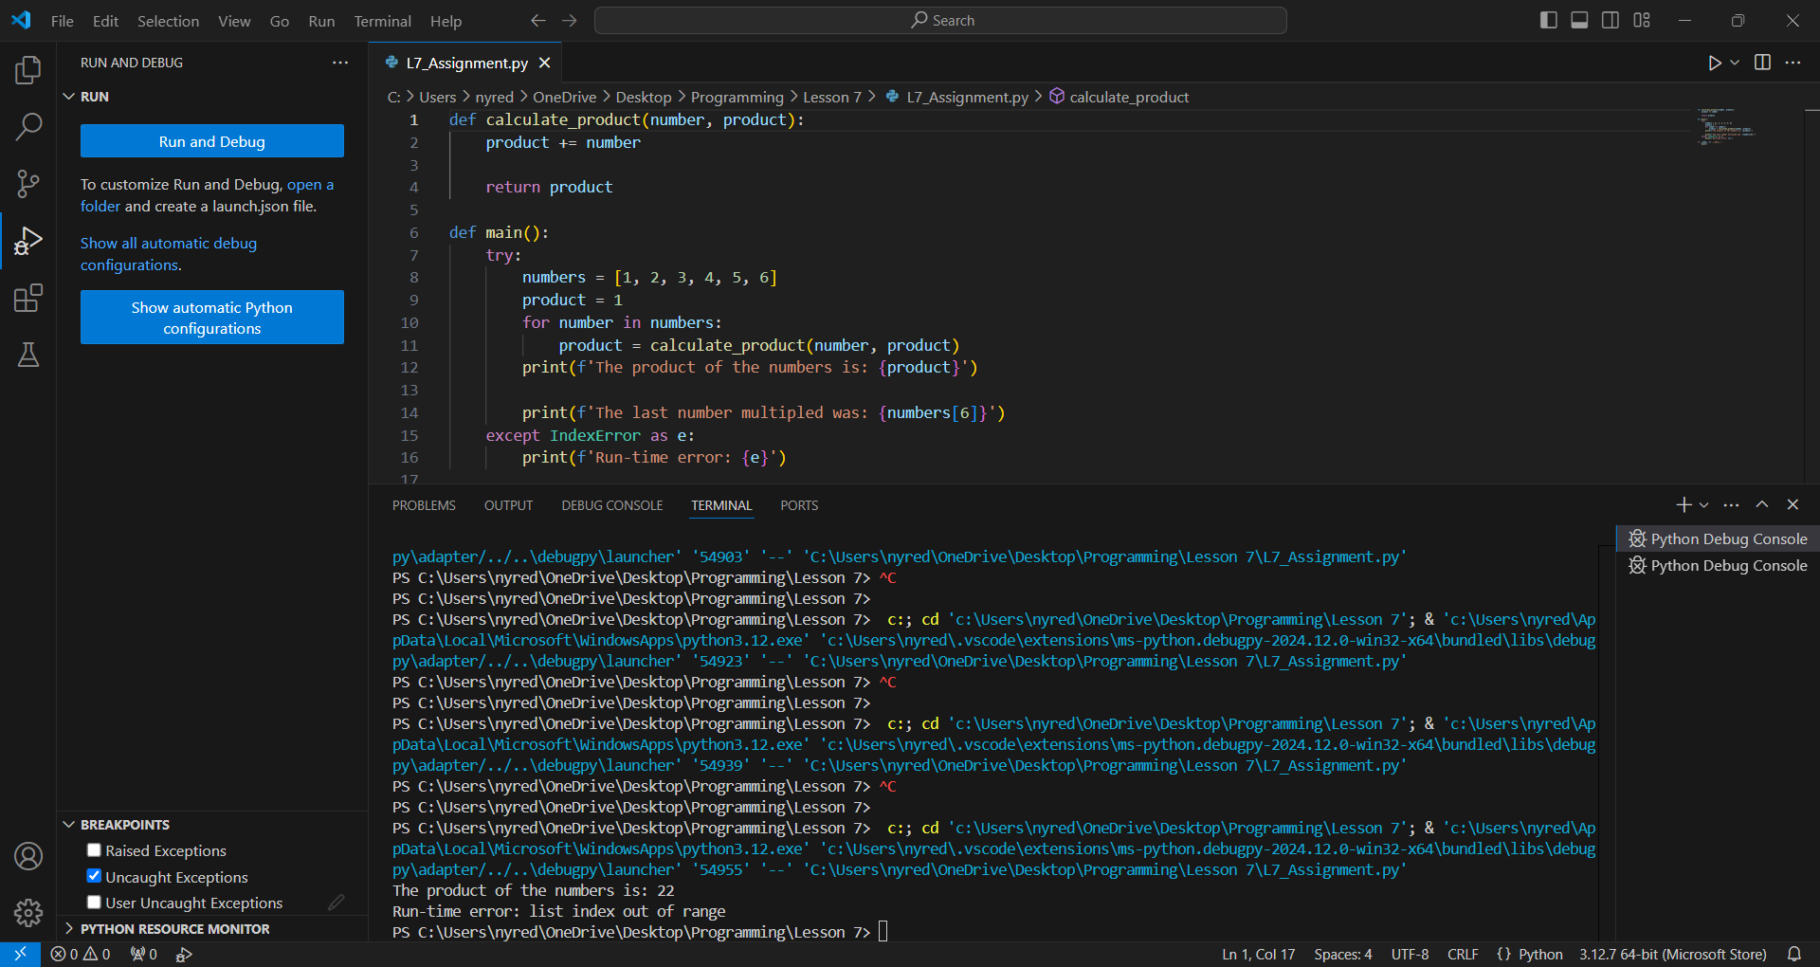

All the syntax errors and the ‘NameError’ are resolved, but the calculation is incorrect and the IndexError should not occur. First, I changed the ‘+=’ in the calculate_product function to ‘*=’.

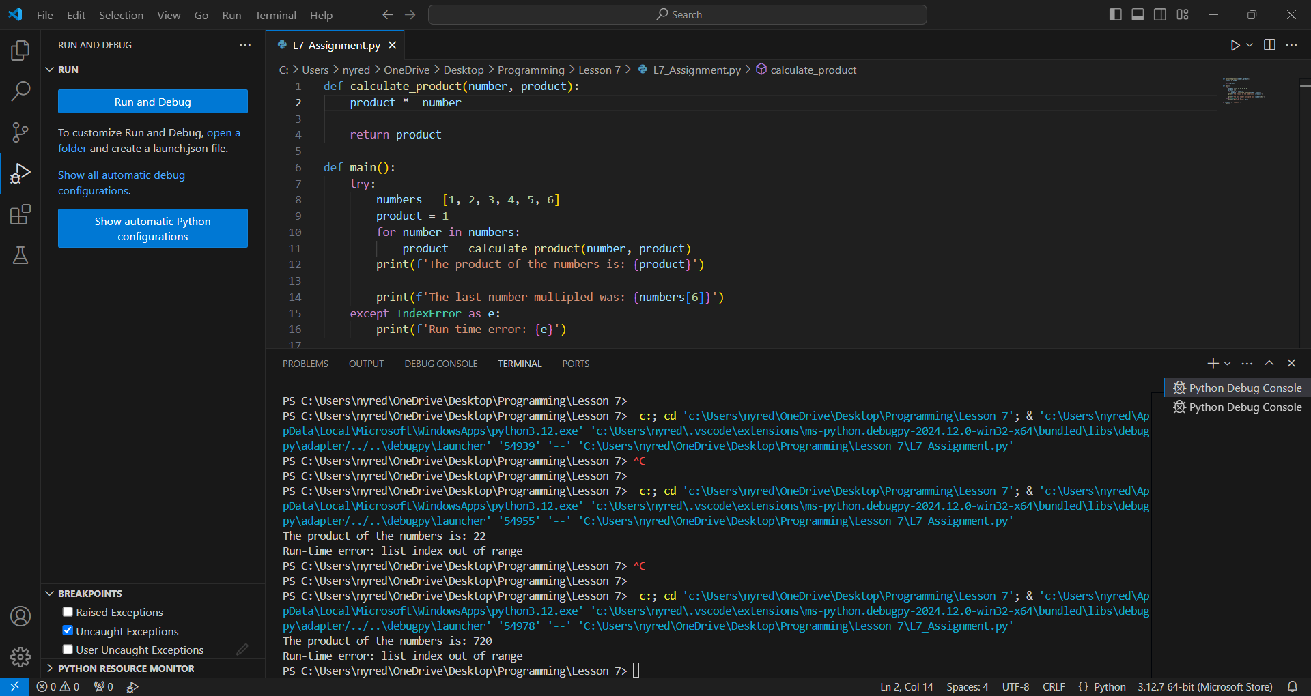

Now that the calculation is correct, I changed the last number multiplied to 0, which gave me a last number multiplied of 1. Then I tried a last number of 1, which gave me a last number of 2. Finally, I tried a last number of -1 and that gave me the correct last number multiplied of 6.

